

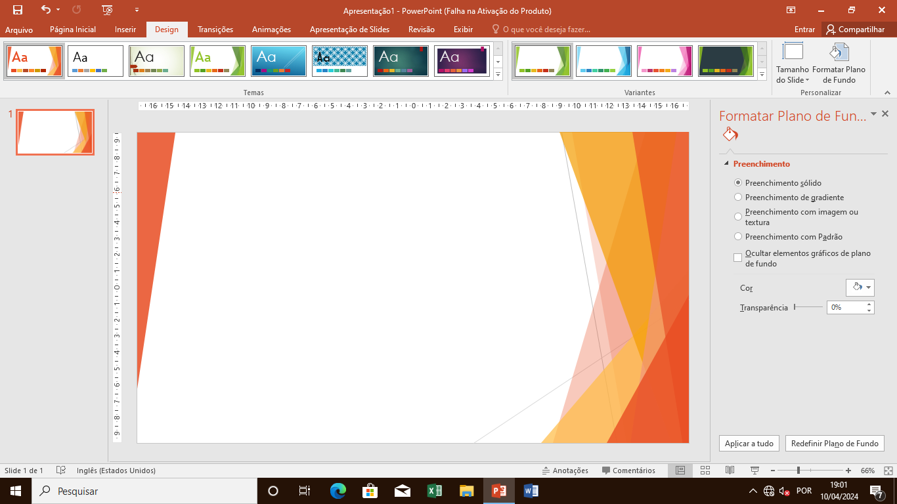
PROFESSIONAL CENTER
CREDENCIAL Nº 124.01/LA MAPESS/INEFOP

COMPTEC
Declaration Nº80

English adviser
________________________
Sebastião Maral Monteiro

Direction ________________________
Bernado Monteiro Manassa
C.F.T.P COMPTEC- Credencial nº 124.01/LA MAPESS/INEFOP. cftpcoptecz3@gmail.com
We declare that TITO QUINZEMBE, has completed the Beginner Level, with 150 hours, six months, with an overage of 18, on a maximum scale of 20.

COMPTEC – Luanda 06th September 2024

